🤖 Intelligent Agents in D2L Brightspace
Automatically email students based on activity (or lack of activity).

📌 Why Use Intelligent Agents?
✅ Encourages Student Engagement – Sends reminders to students who haven't logged in or participated.
✅ Saves Time – Automates outreach instead of manually emailing students.
✅ Provides Personalized Support – Helps struggling students stay on track.

🛠 How to Set Up an Intelligent Agent in D2L Brightspace

Navigate to Intelligent Agents
- Go to Edit Course → Click “Intelligent Agents” or under the Course Tools navbar, click “Intelligent Agents”.
- Click “New Agent” to create an automated email trigger.
Define Agent Settings
- Name the Agent (e.g., “Inactive Student Reminder”).
- Check "Agent is Enabled" to activate it.
Set the Trigger Conditions
- Under “Criteria” → Select a Condition Type:
  - No Course Login for X Days (e.g., No login for 7 days).
  - No Activity in Content/Assignments/Discussions.
  - Or create a new Release Condition that meets your needs.
    - Refine the Condition (e.g., only notify students below 70% in a quiz).
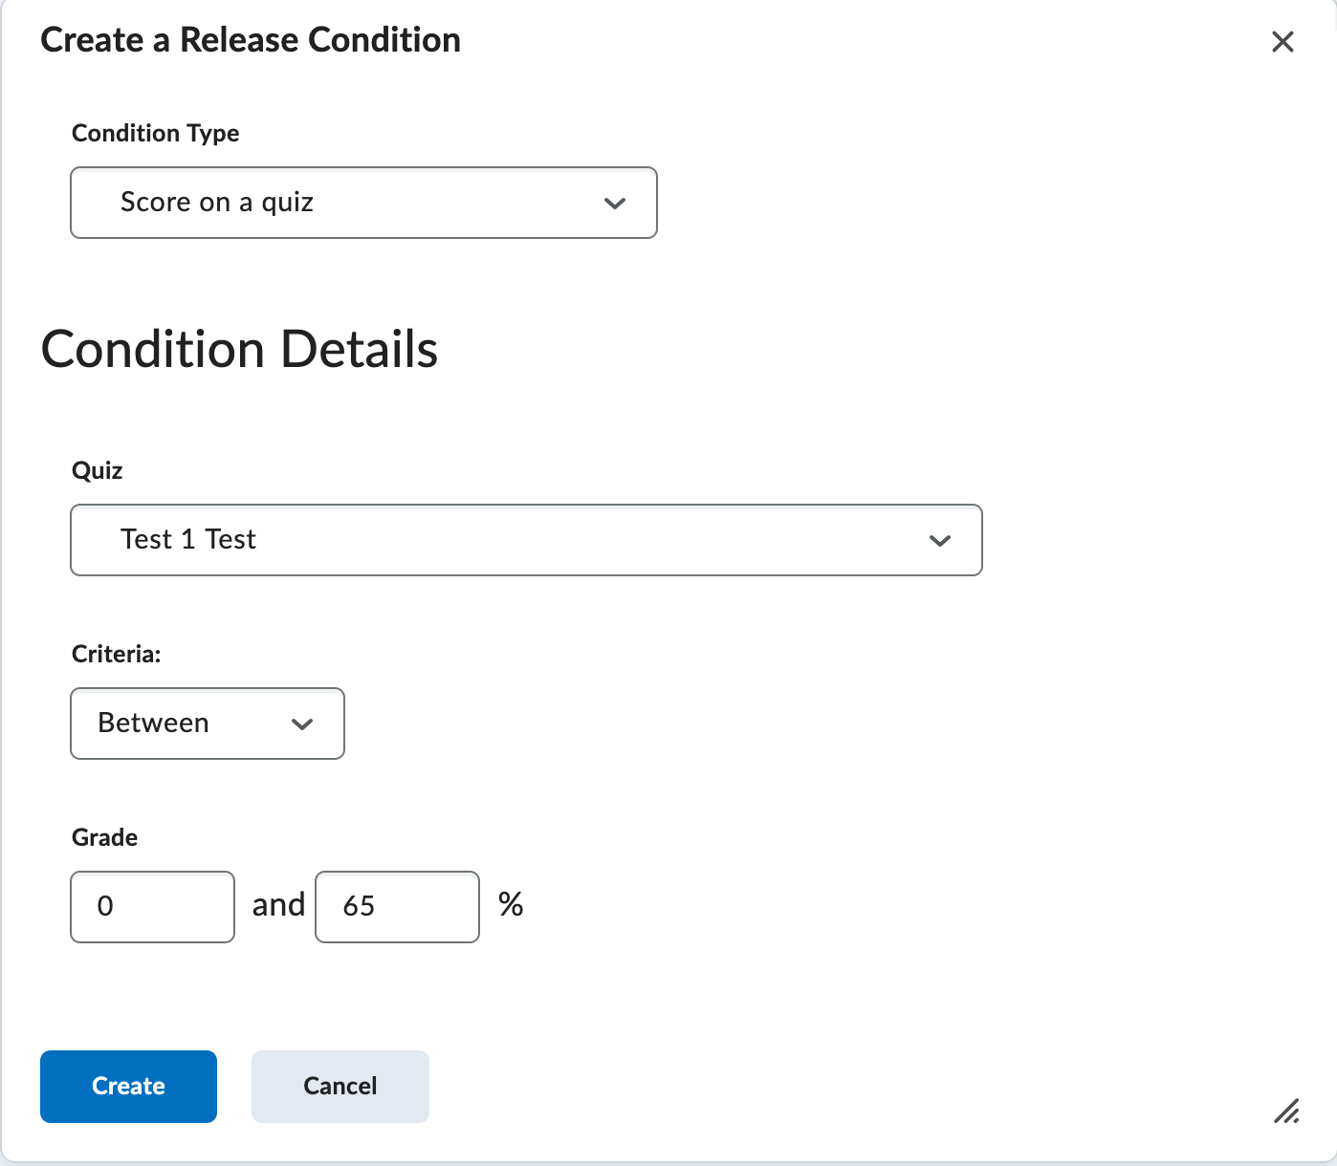
Set the Actions
- Under “Actions” decide if this action will only take place the first time the agent is satisfied or every time. Review the hint for more information.
Create the Email Notification
- Under “Actions” → Choose "Send an Email".
- Customize the Message:
- Use replace strings to personalize (e.g., {InitiatingUserFirstName).
- When sending an email, always use {InitiatingUser} replacement string for To:
- Example Email:
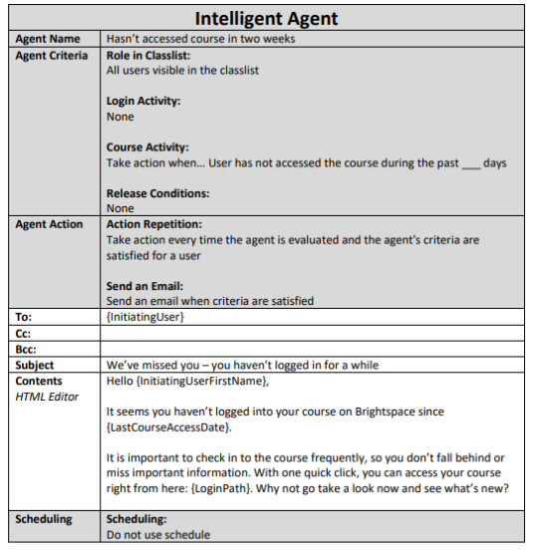
- Click Save and Close.
- Run it manually or schedule it to run daily/weekly.

Practice Runs
- If you prefer, you can run Practice Run’s instead of sending out emails if you prefer just to view results
- Emailing or adding a frequency isn’t needed to get results with Practice Run’s.
- To run a Practice Run > click the dropdown arrow next to the Intelligent Agent
  - Click Practice Run
  - Confirm you want to run the Practice Run of the Intelligent Agent by clicking the blue button “Run”.
Results
- Click X# users identified to view results of the Intelligent Agent
- Click into (Edit) the Intelligent Agent to view history by clicking View History in the upper right corner of the Intelligent Agent.

🛠 Example Use Cases for Intelligent Agents
Scenario | Condition
Send an email to students who haven’t logged in for 7 days. | "No Course Login for 7 Days"
Notify students who haven't submitted an assignment by the due date. | "No Submission for Assignment X"
Encourage students who scored below 70% on a quiz. | "Grade Below 70% in Quiz 1"
Congratulate students scoring 90% or higher. | "Grade Above 90% in Quiz 1"

What replace strings can I use in the subject and message?
The following are replacement strings you can use in the subject line and the email message.
{OrgName} - The name of the organization.
{OrgUnitCode} - The code for the org unit.
{OrgUnitName} - The name of the org unit.
{OrgUnitStartDate} - The start date specified for the org unit.
{OrgUnitEndDate} - The end date specified for the org unit.
{OrgUnitId} - The id for the org unit.
{InitiatingUser} this should ALWAYS be used in the To: line of your email
{InitiatingUserFirstName} - The first name of the initiating user.
{InitiatingUserLastName} - The last name of the initiating user.
{InitiatingUserUserName} - The username of the initiating user.
{InitiatingUserOrgDefinedId} - The Org Defined ID of the initiating user.
{LoginPath} - The address of the login path for the site.
{LastCourseAccessDate} - The date the initiating user last accessed the course.
{LastLoginDate} - The date the initiating user last logged in.

💡 Additional Tips & Best Practices
✅ Use Replace Strings – {FirstName} makes emails feel personal.
✅ Test Before Enabling – Use “Practice Run” to preview which students meet conditions.
✅ Keep Messages Supportive – Avoid sounding punitive; focus on encouragement.

To view templates for Intelligent Agents – head over the Online Learning page on Institution’s website and find the Tutorial for Intelligent Agents.

https://intranet.example.edu/online-learning/_documents/intelligent-agents-templates.pdf

